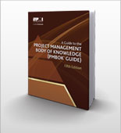
New Editions of PMI’s Foundational Standards
In January 2013, PMI will publish A Guide to the Project Management Body of Knowledge (PMBOK® Guide)—Fifth Edition, The Standard for Program Management—Third Edition, and The Standard for Portfolio Management—Third Edition.
For more information go to http://www.pmi.org/PMBOK-Guide-and-Standards.aspx

